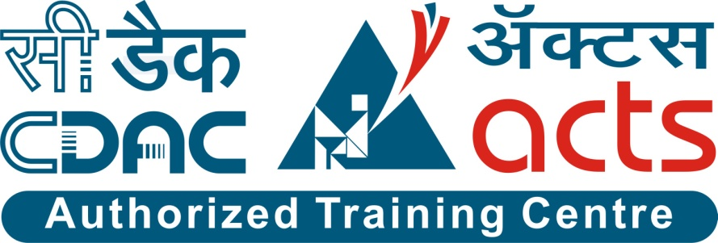

Project Name: E-Blood Bank Management System

Branch E-DAC May- 2021.

Documentation On

**“**E-Blood Bank Management System**”**

E-DAC May 2021

**Guided By: Snehal Somwanshi**

Submitted By :

**Group No: 18**

* **Kanchan Salampure 210943020033**
* **Sakshi Gandalwar 210943020079**
* **Rohit Bachche 210943020074**
* **Rohit Jadhav 210943020073**

**Table of Contents**

**1. Introduction 4**

1.1 Document Purpose **4**

1.2 Project Background **4**

1.3 Aim & Objectives **4**

**2. Business Requirements Overview**…………………………………………………………**5**

**3.Functional Requirements** **5**

3.1 Admin Module **5**

3.2 Donor Module **6**

3.3 Patient Module **6**

3.4 Staff Module……………………………………………………………………………………...**6**

**4.** **Non-Functional Requirement………………………………………………………………6**

**5. Use Case Diagram 7**

5.1 Admin **7**

5.2 Donor **8**

5.3 Patient **9**

5.4 Staff………………………………………………………………………………………………**10**

**6. Database Design 10**

1 User **10**

2 Patient Request **10**

3 Donation………………………………………………………………………………… **10**

4 Camp **11**

5 Blood Bank **11**

6 Blood Inventory **11**

**7. E-R Diagram………………………………………………………………………………………12**

**8. Snapshots 13**

**9. Conclusion 25**

**List of Figures**

**Use Case Diagrams 7**

Fig 1 Admin 7

Fig 2 Donor 8

Fig 3 Patient 9

Fig 4 Staff……………………………………………………………………………………………10

Fig 4 ER Diagram ………………………………………………………………………...12

1. **Introduction:**
   1. **Document Purpose:**

This document communicates the business requirements and scope for developing E-BLOOD BANK System. The scope of this document is to define the functional and non functional requirements, business rules and other constraints requirements.

## Project Background:

Blood donation is required during an organ transplant , accidents , cancer treatment etc. For blood donation , one needs to visit blood bank. The manual Blood donation system has many disadvantages which includes it is too time consuming often lead to error prone results, consumes lots of manpower ,lack donor information, retrieval of data takes a lot of time ,percentage of accuracy is less. In the time of emergency it becomes difficult to approach the right donor. Rare blood groups are not available all the time at all blood bank and recipients find difficulties to track the right blood donor.

## Aim & Objectives:

The main objective of this project is building a website which will help people who are in need of transfusion or willing to donate their blood. This system not only maintains information of blood banks but also maintains information of blood camps which makes blood transfusion process easier.

This online blood donation management system maintains the list of blood donors and also helps the recipients to track the right donor easily. User can also register as donor can check for donor camps.

1. **Business Requirements Overview:**

* E-Blood bank is a public web application.
* E-Blood bank System will be opened to the city, but in the phase 1, the main target is in the particular city area.
* There are mainly two types of user. One is Donor and one is Patient
* Patients can check for the blood availability of required blood group in particular city area.
* Donor can search for the blood camps and hospitals available near his/her residence area.
* E-Blood Bank System provides the functions to connect the patients/hospital and the blood bank efficiently.
* E-Blood Bank System could be maintained by Administrator and blood bank staff.

# Functional Requirements Overview:

Online E-Blood Bank Management System consists of four modules described as below.

1. Admin Module
2. Donor Module
3. Patient Module
4. Staff Module

# **Admin Module**

# Admin can login by his/her id and password.

* Admin can change his/her own personal details (eg.id, password, contact details)
* Admin can add staff and hospital's and keep the record of all the details
* Admin manage the view off website additional information like benefits of blood donation to encourage people do donate blood
* Admin generate the report of months summary and total income at end of the month.
* Admin keep the record of all transactions of payments
* Admin upload blood reports of Donor and if required suggestions is given .

# **Donor Module**

* Donor can register as new donor.
* Donor can login to check his/her blood reports.
* If Donor has donated blood before then he/she will request one bag free in next two years.
* Donor can see sheduled blood donation camp near his/her area.
* Donor will get next camp notification 3 months after he/she has donated blood.

# **3.3 Patient Module**

* Patient can register and login.
* Patient can view availability of blood groups and blood group details.
* Patient can request for free blood bag if he/she donated blood in last two years.
* Patient can book a blood bags according to his/her need by paying some minimum amount which is not refundable.
* Patient can check his/her billing details by using login.
* Patient can send requests for blood according to his needs.

# **Staff Module**

* Staff can register and login.
* Staff can manage the camps in different area in regular intervals.
* Staff can send the notification to about camp’s to donors who can donate.
* Blood bank staff can manage the blood bags details according to the availability of blood bags.

1. **Non-Functional Requirement:**

* The website should use professional design, look and feel and color scheme.
* Users will have no limitations for accessing the application through Internet. The portal being an internet application, it is difficult specify exact number of visitor or users. Hence we will target the system to support between 5 and 10 million users on launch of phase 1.
* Being a public website, the site must follow general usability guidelines for menus, navigation, colors, links and other actions provided on the screens.
* The system should be designed in such a manner that user will be able to complete tasks in minimum number of steps.
* This site is available for 24 hours.

## 5. Use-Case Diagram

**5.1 Admin:**

Fig. :Use Case Diagram for Admin

## 5.2 Donor:

Fig. :Use Case Diagram for Donor

**5.3 Patient:**

Fig. :Use Case Diagram for Patient

**5.4 Staff :**

Fig. :Use Case Diagram for Staff

**6. Database Design:**

**1] login table**

|  |  |  |  |  |  |
| --- | --- | --- | --- | --- | --- |
| Field | Type | Null | Key | Default | Description |
| User_ID | int | NO | PRI |  | User ID |
| User_name | varchar(65) | NO |  |  | User Name |
| Password | varchar(75) | NO | UNI |  | Password |
| User_type | varchar(45) | NO |  |  | Type of User(Admin/Staff/Donor/Patient) |
| First_name | varchar(65) | NO |  |  | First Name of User |
| Last_name | varchar(65) | NO |  |  | Last Name of User |
| Gender | varchar(65) | NO |  |  | Gender of User |
| DOB | date | NO |  |  | Date of Birth of User |
| Blood_type | varchar(45) | NO |  |  | Blood Type |
| Email_ID | varchar(100) | NO |  |  | Email ID of User |
| Address | varchar(100) | NO |  |  | Address of User |

**2]Patient Request table**

|  |  |  |  |  |  |
| --- | --- | --- | --- | --- | --- |
| Field | Type | Null | Key | Default | Description |
| PatientRequest_ID | int | NO | PRI |  | Patient Request ID |
| Patient_ID | int | NO | MUL |  | Patient ID |
| Date | date | YES |  | NULL | Date of request |
| Quantity | int | YES |  | NULL | Quantity of blood bags |
| Status | varchar(40) | YES |  | NULL | Status of availability |
| Paymentmode | varchar(85) | YES |  | NULL | Mode of payment |
| Transactionmode | varchar(85) | YES |  | NULL | Mode of transaction |
| PaymentStatus | varchar(65) | YES |  | NULL | Status of payment |

**3]Donation table**

|  |  |  |  |  |  |
| --- | --- | --- | --- | --- | --- |
| Field | Type | Null | Key | Default | Description |
| Donation_ID | int | NO | PRI |  | Donation ID |
| Donor_ID | int | NO | MUL |  | Donor ID |
| Date | date | YES |  | NULL | Date of donation |
| Quantity(Bags) | int | YES |  | NULL | Quantity of bags |
| BloodReport_Image | longblob | YES |  | NULL | Blood Report |

**4]Camp table**

|  |  |  |  |  |  |
| --- | --- | --- | --- | --- | --- |
| Field | Type | Null | Key | Default | Description |
| Camp_ID | int | NO | PRI |  | Camp ID |
| Name | varchar(45) | NO |  |  | Name of Camp |
| OrganizationName | varchar(85) | YES |  | NULL | Organization Name |
| Date | date | YES |  | NULL | Date of camp organized on |
| Time | time | YES |  | NULL | Time of starting of camp |
| Description | varchar(100) | YES |  | NULL | Description about camp |

**5]Blood Bank table**

|  |  |  |  |  |  |
| --- | --- | --- | --- | --- | --- |
| Field | Type | Null | Key | Default | Description |
| BloodBank_ID | int | NO | PRI |  | Blood Bank ID |
| Name | varchar(85) | NO |  |  | Name of Blood Bank |
| Address | varchar(100) | YES |  | NULL | Address of Blood Bank |
| Contact_No | varchar(85) | YES |  | NULL | Contact number of blood bank |
| Email | varchar(100) | YES |  | NULL | Email of blood bank |
| Location | varchar(45) | YES |  | NULL | Location of bank |

**6]Blood Inventory table**

|  |  |  |  |  |  |
| --- | --- | --- | --- | --- | --- |
| Field | Type | NULL | Key | Default | Description |
| BloodInv_ID | int | NO | PRI |  | Blood Inventory ID |
| Type | varchar(65) | YES |  | NULL | Type of Blood |
| Quantity(Bag) | int | NO |  |  | Quantity of blood bags |
| BloodBank_ID | int | NO | MUL |  | Blood Bank ID |
| Date | date | YES |  | NULL | Date of blood Inventory |
| Camp_ID | int | NO | MUL |  | Camp ID |

## 7. ER-Diagram:

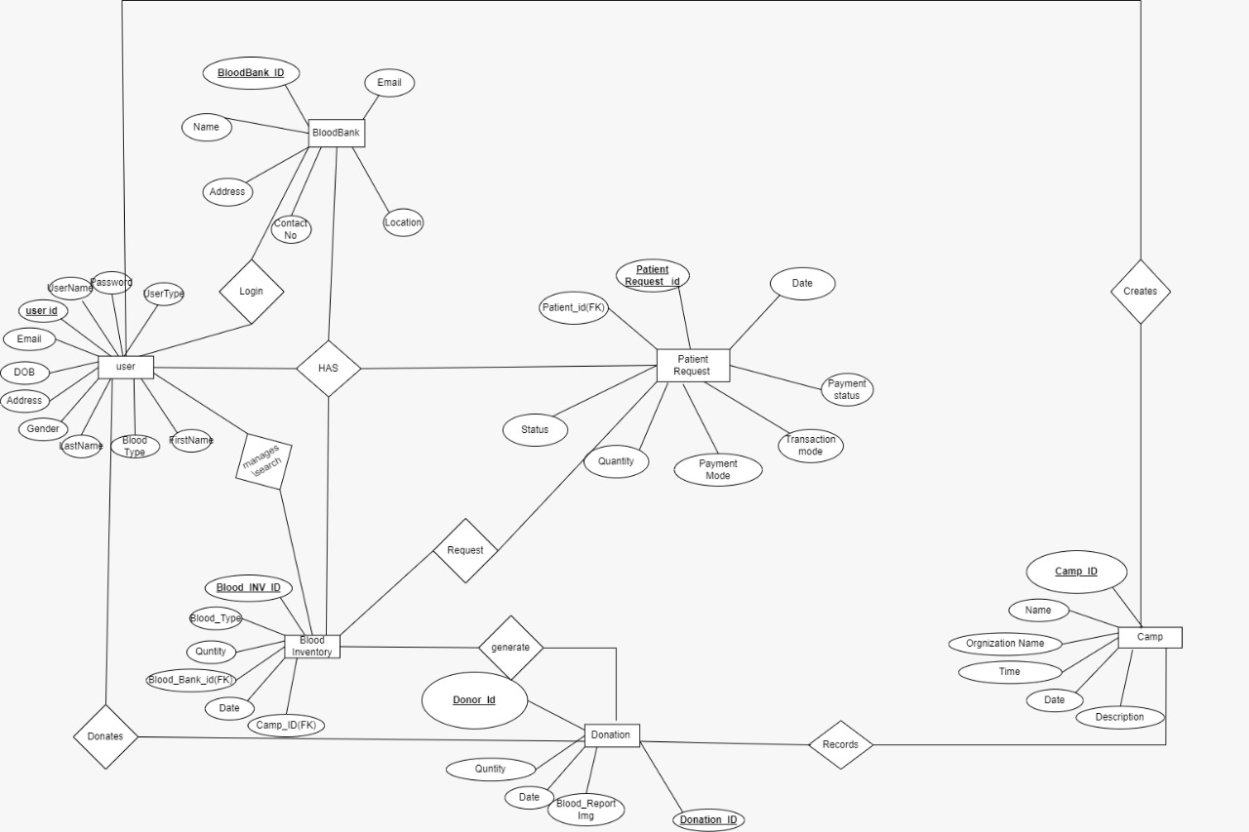

ER-Diagram shows database for E-Blood Bank Management System

**8. Snapshots:**

**8.1 Home Page:**

Following snapshot shows the Home page for E-Blood Bank Management System

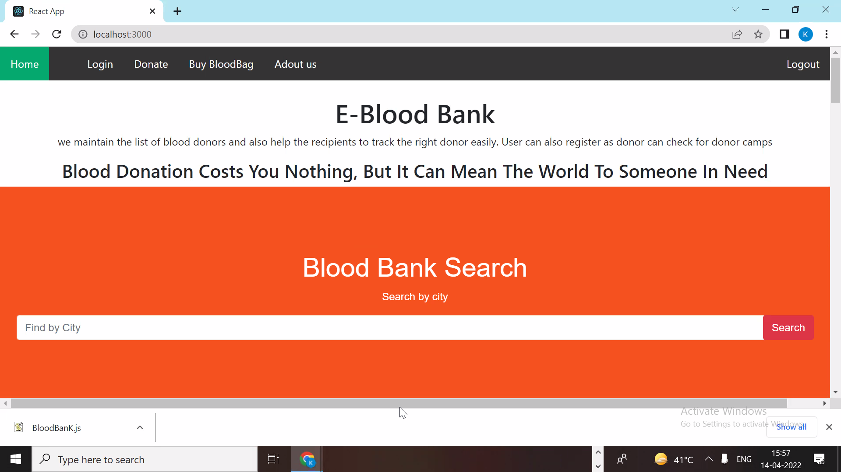

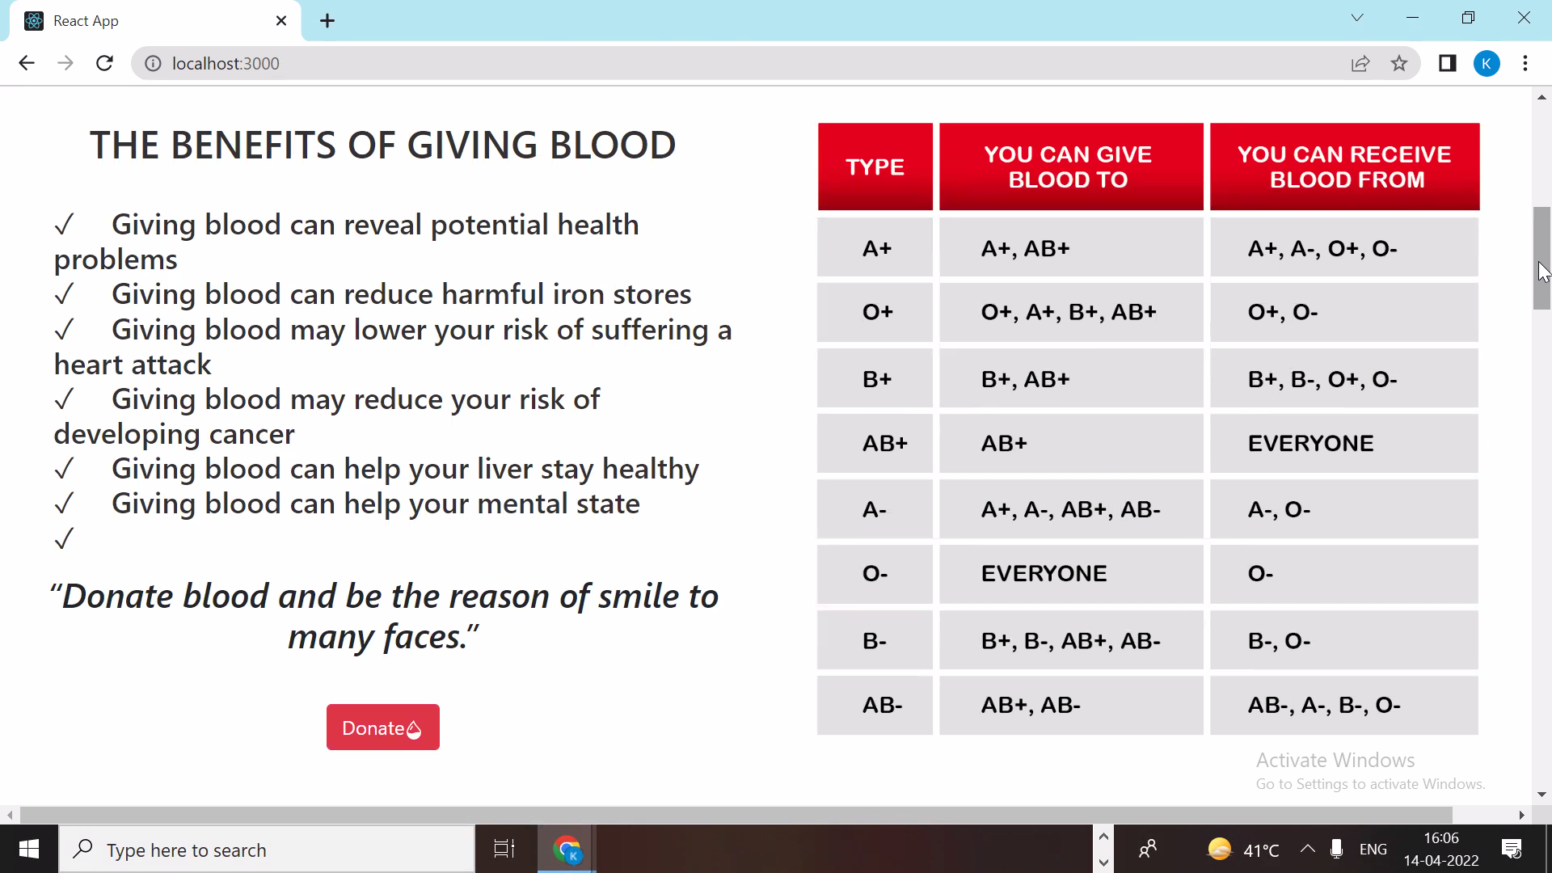

This page contains following controls

* Home
* Login
* Donate
* Buy BloodBag
* About Us
* Logout

**8.2 Contact And About Page**

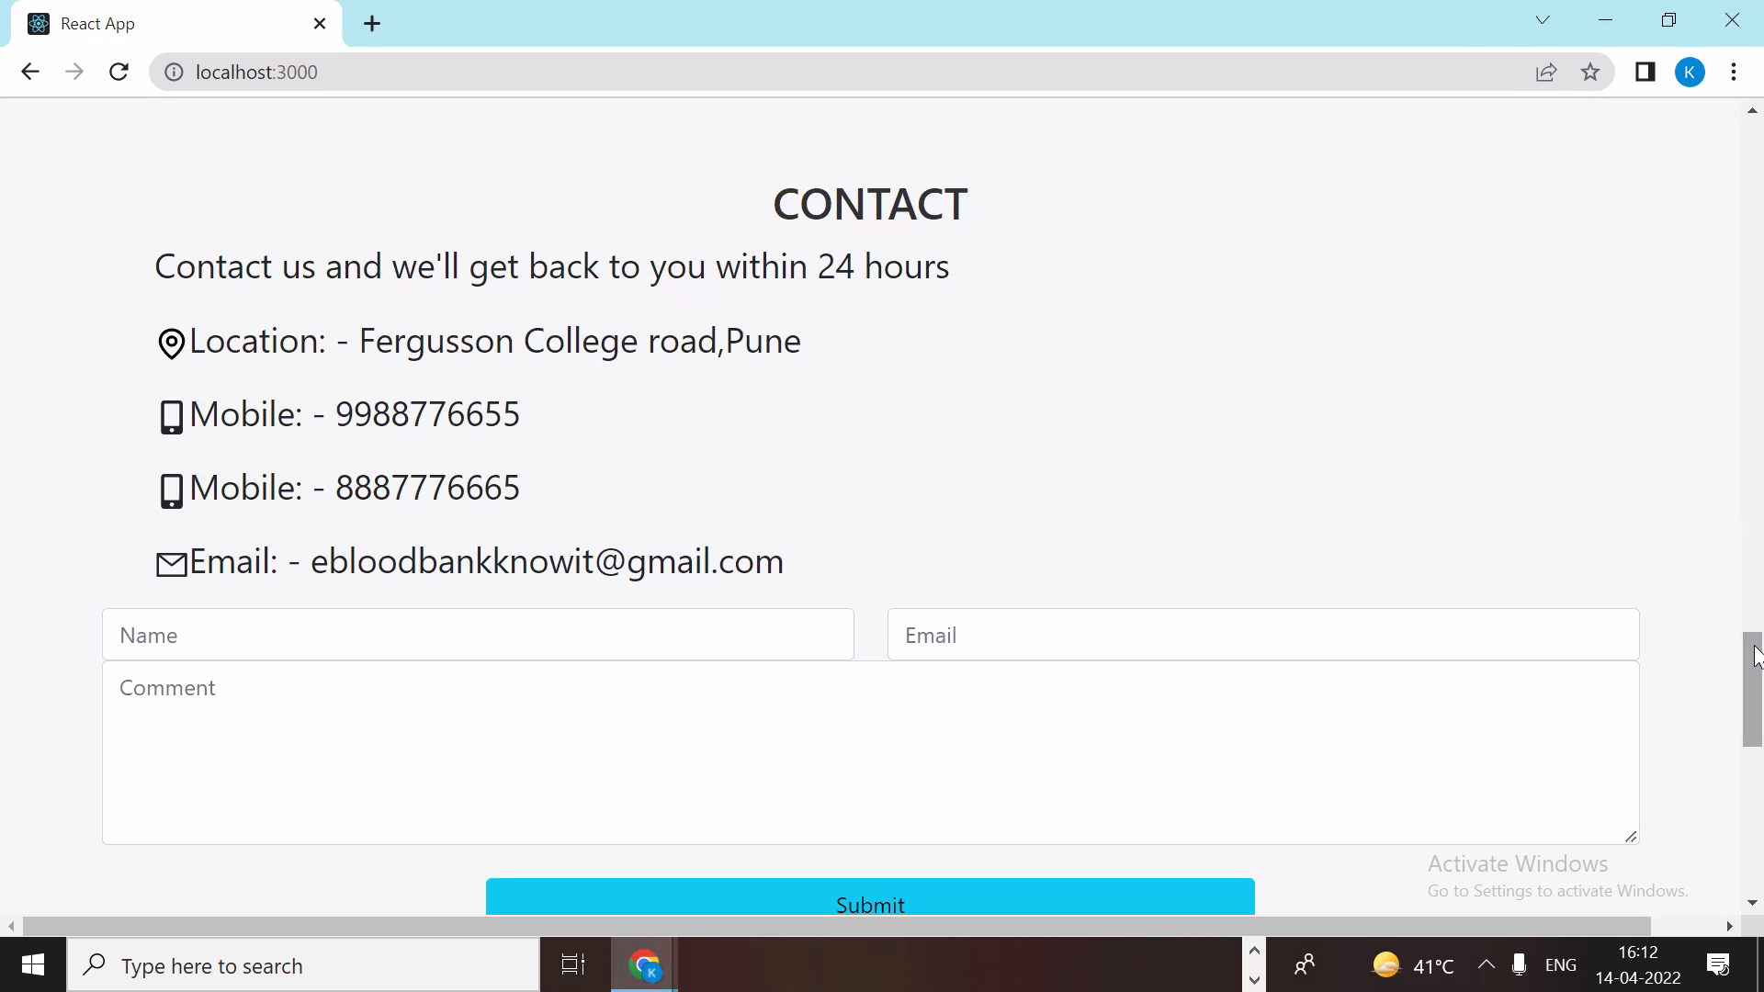

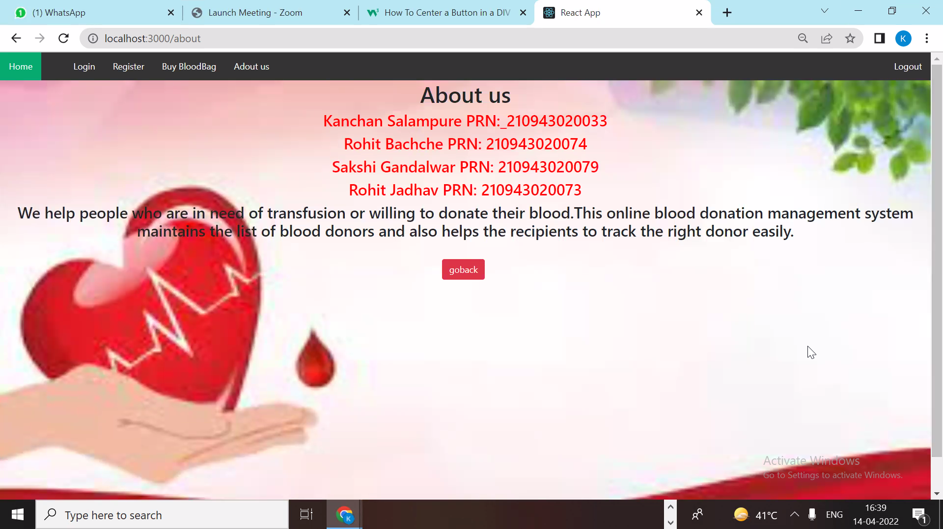

**8.3 Login Page**

Following snapshot shows the Login page for E-BloodBank Management System

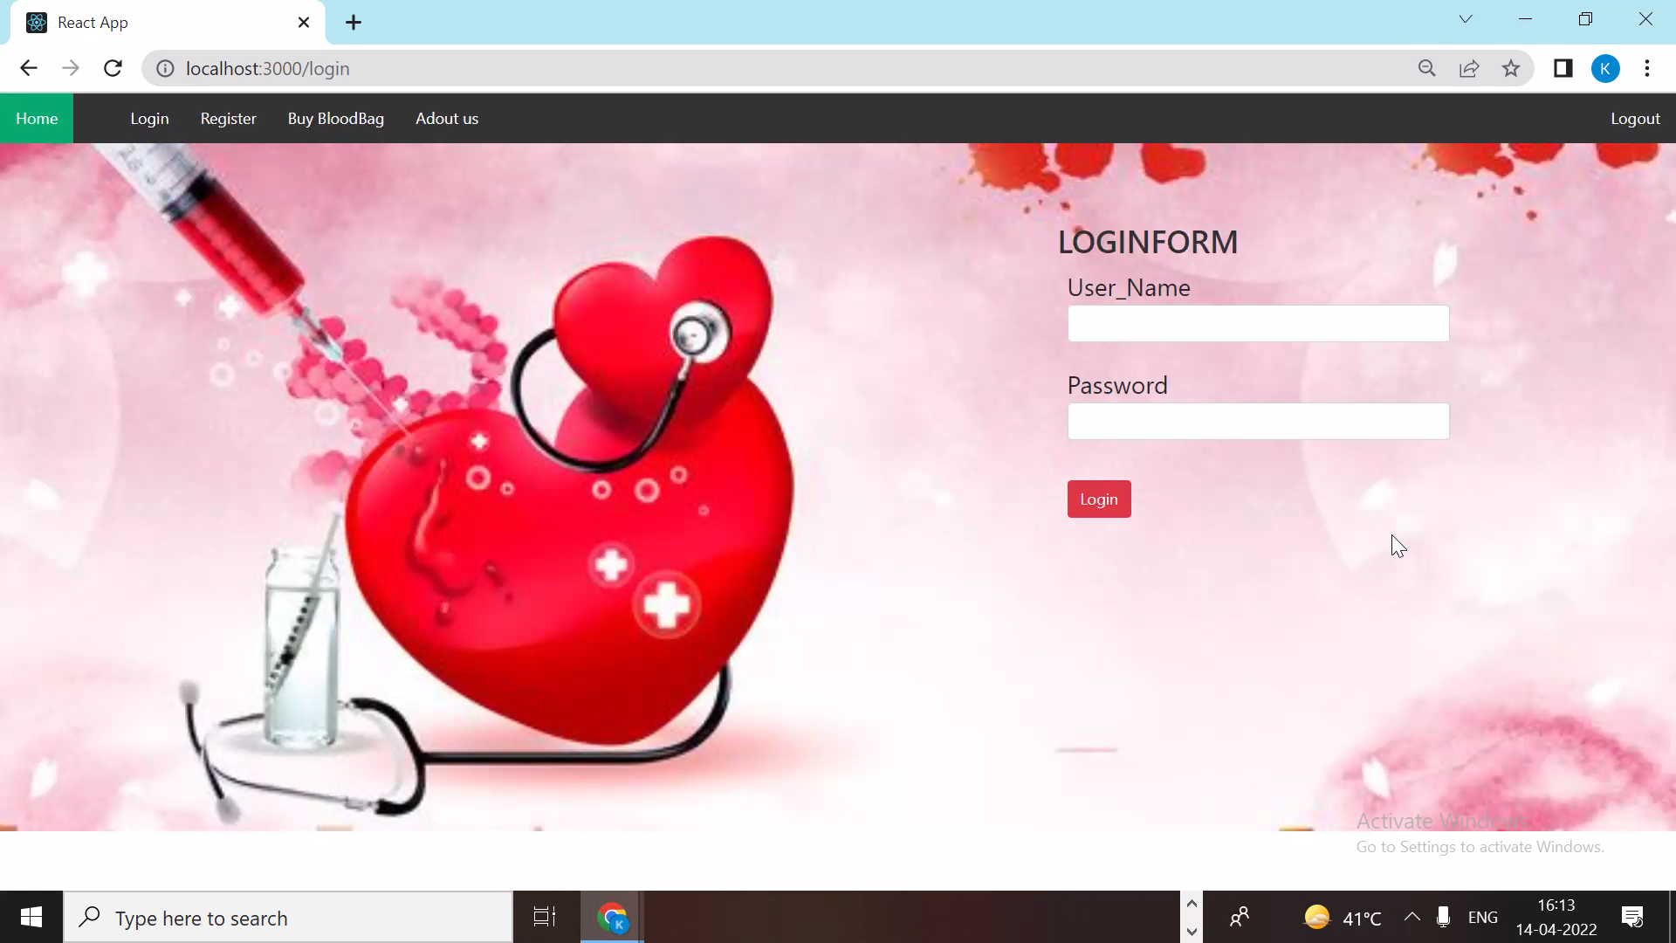

**8.4 User Registration Page**

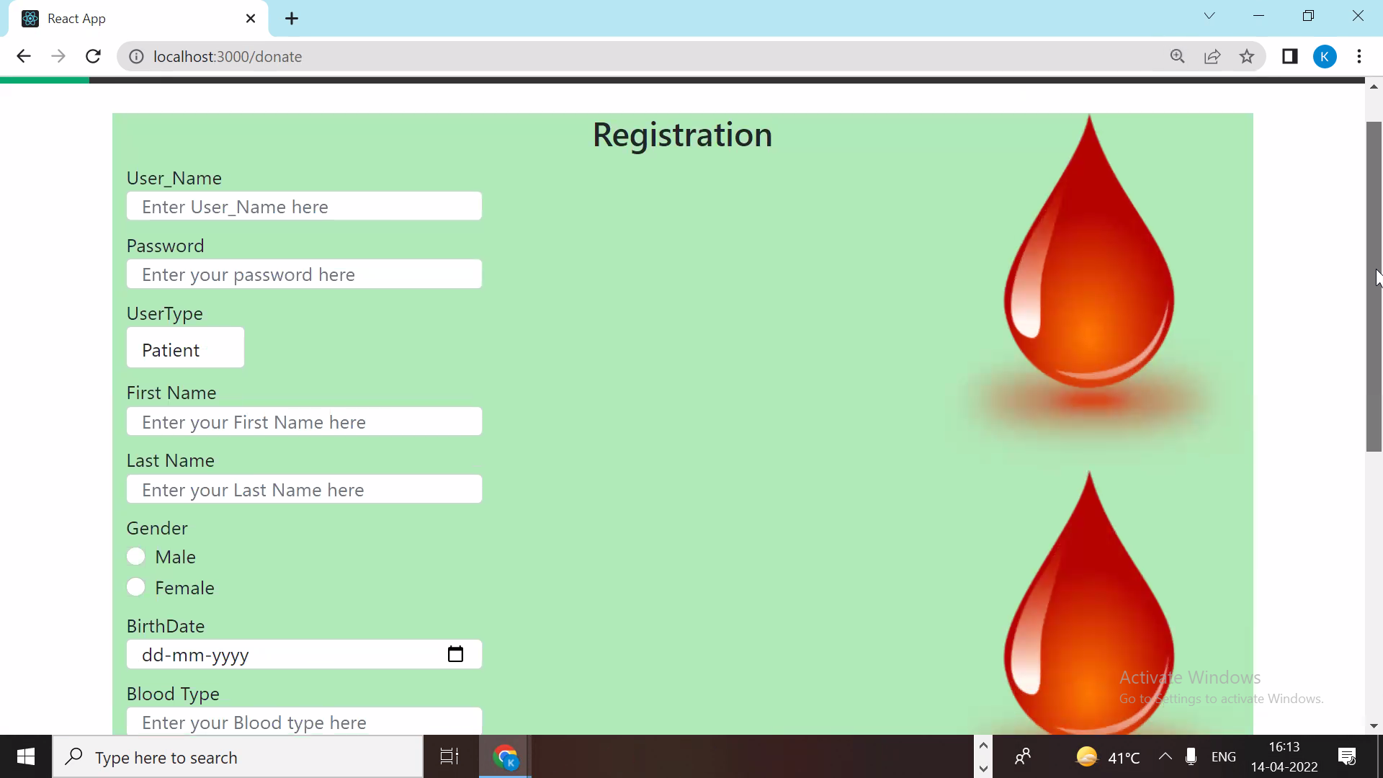

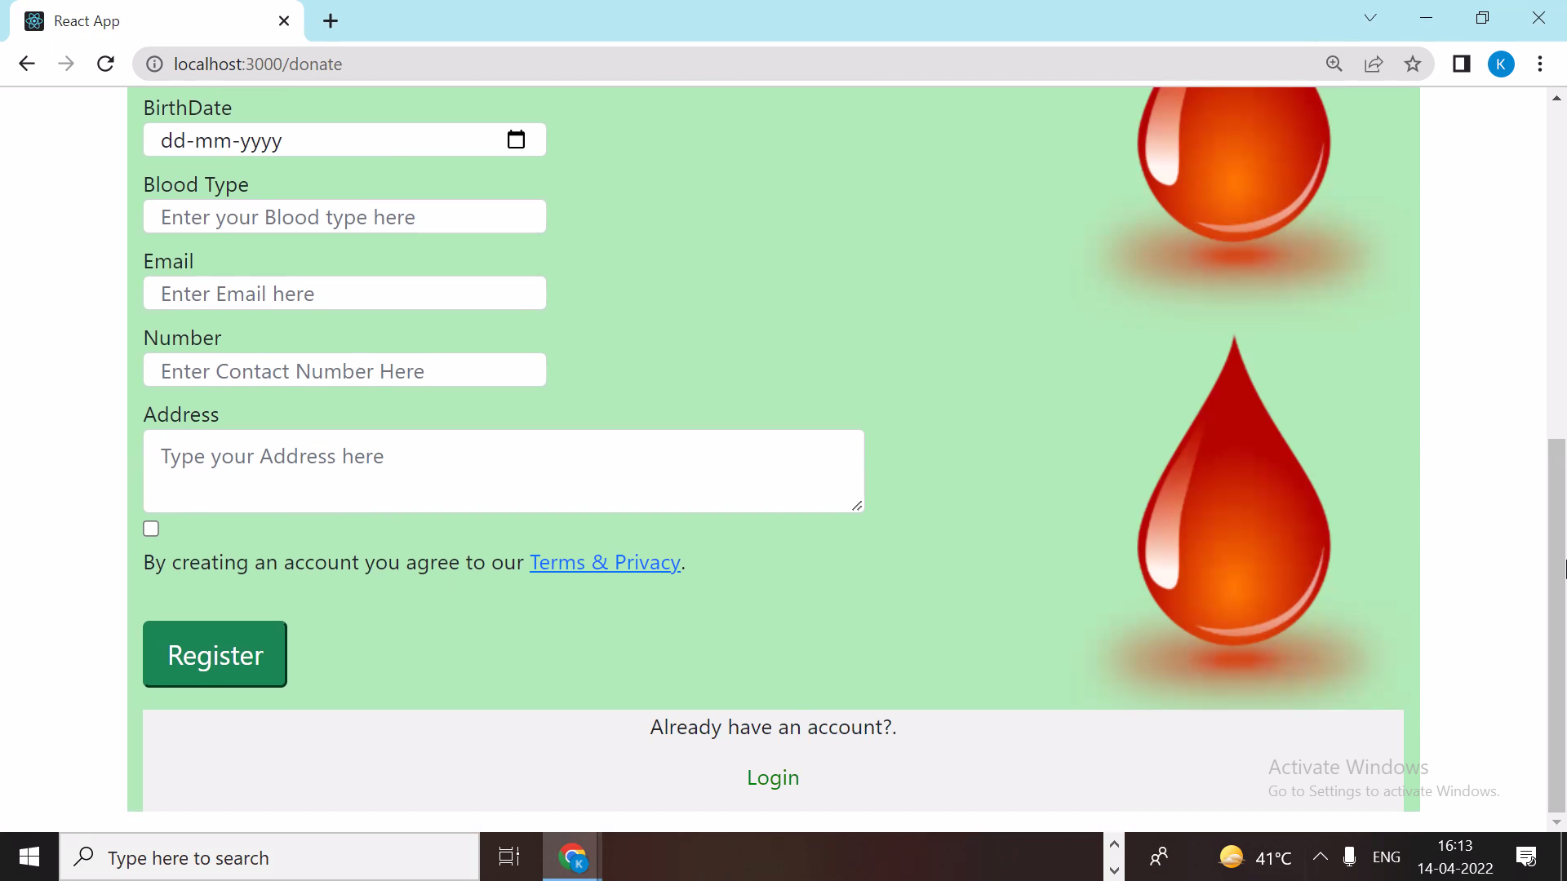

**8.5 Service Page**

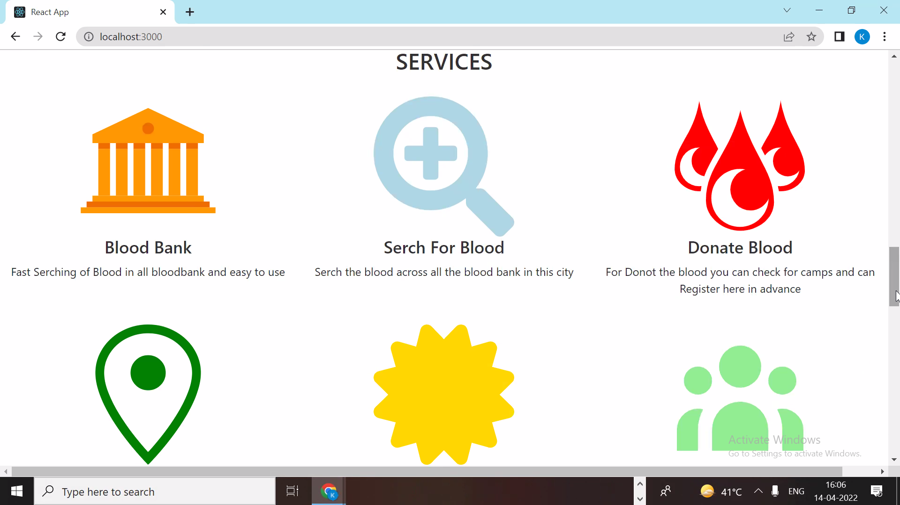

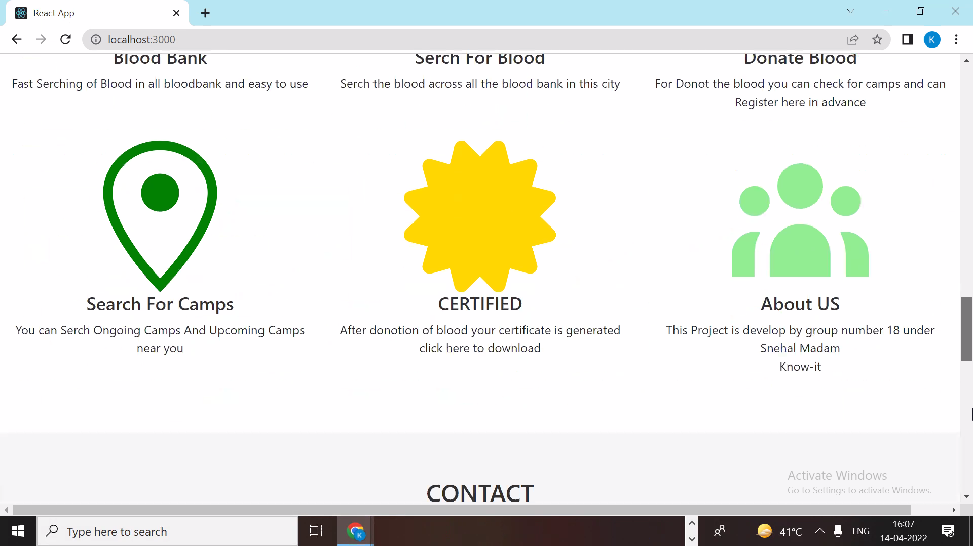

**8.6 Gallery Page**

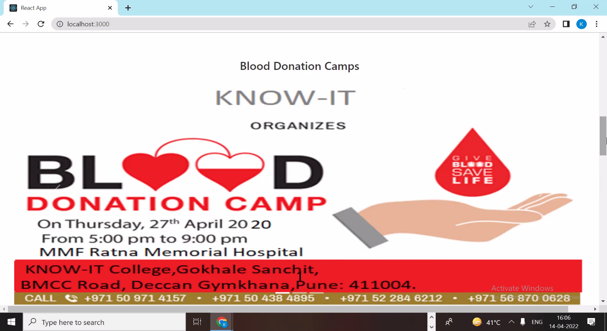

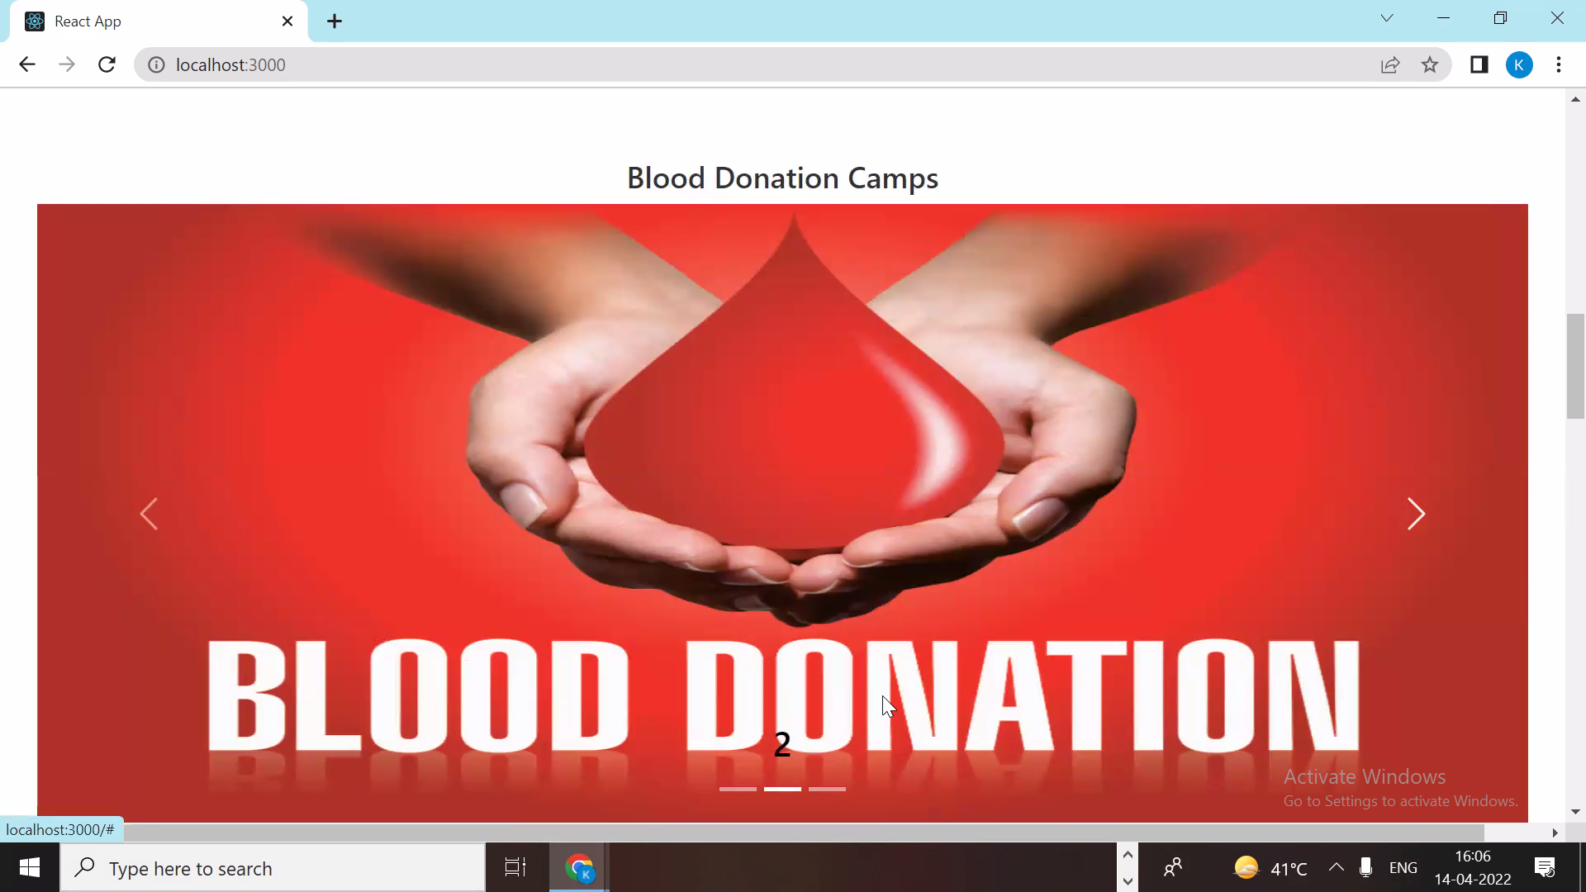

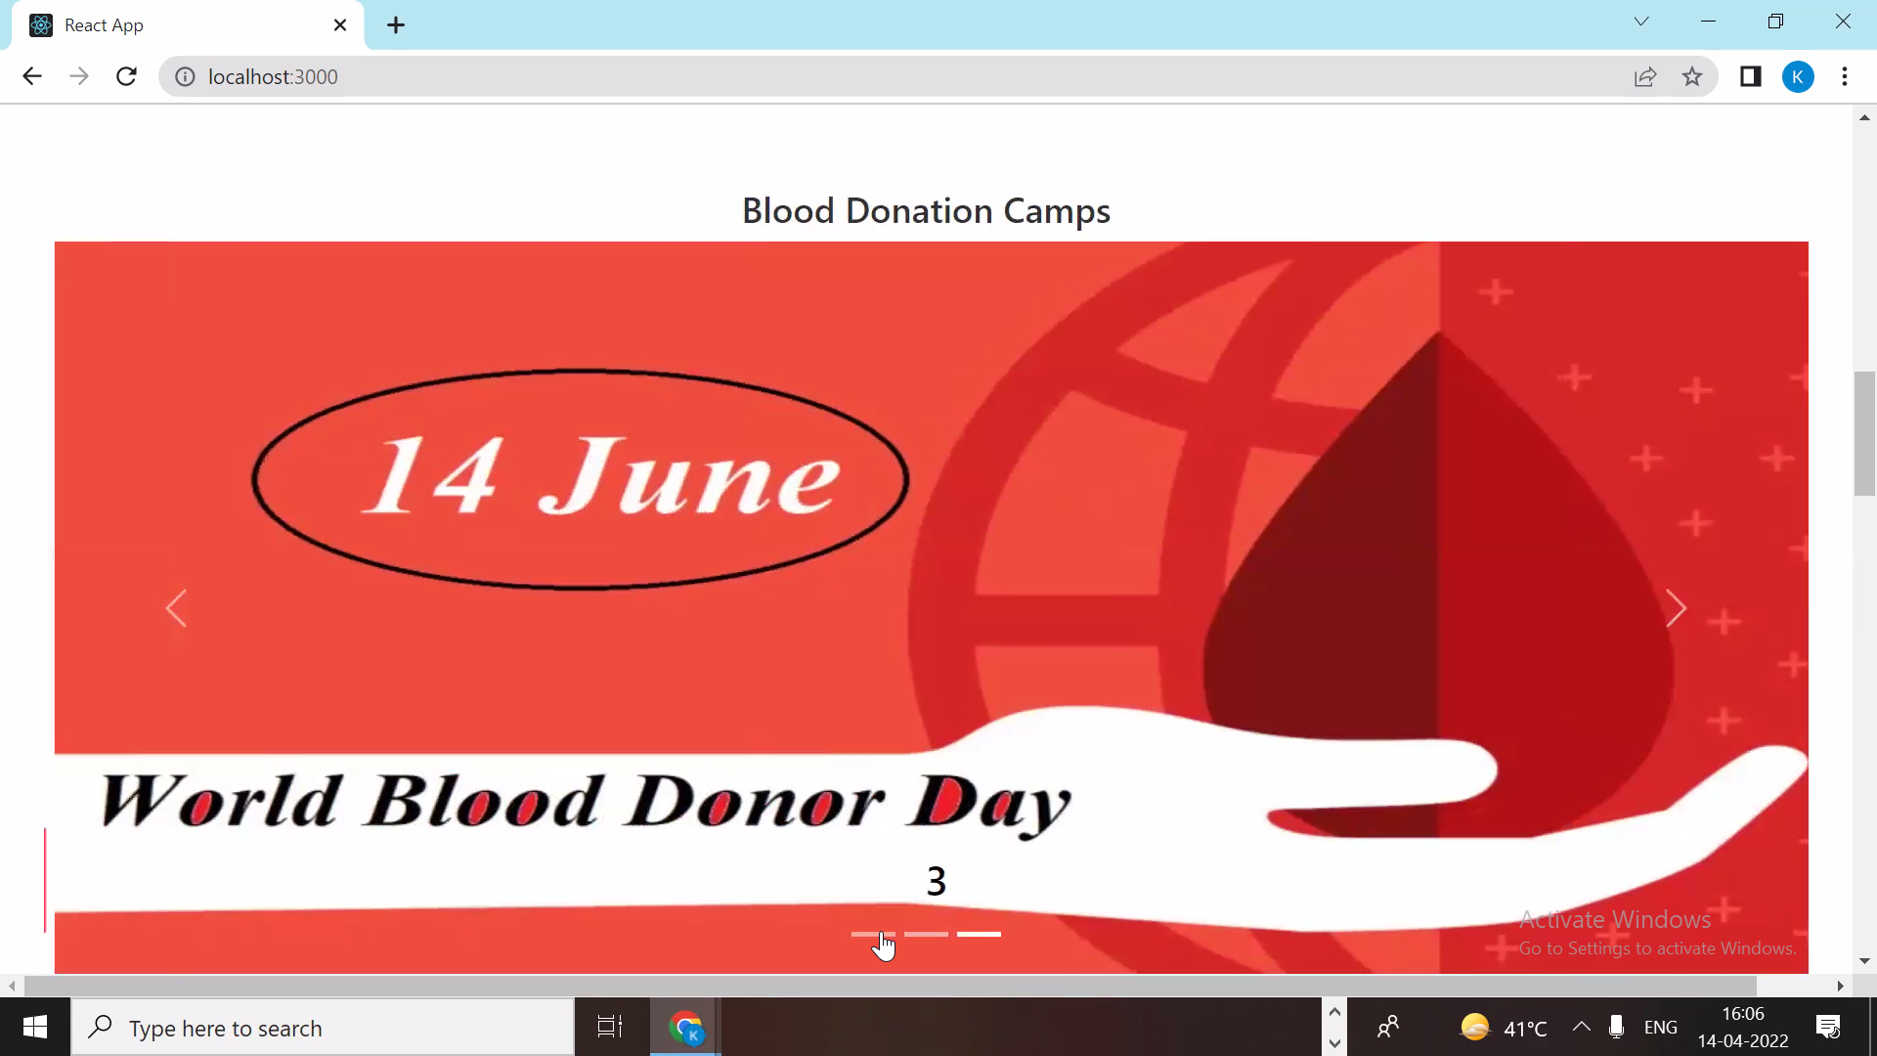

**8.7 Buy BloodBag Page**

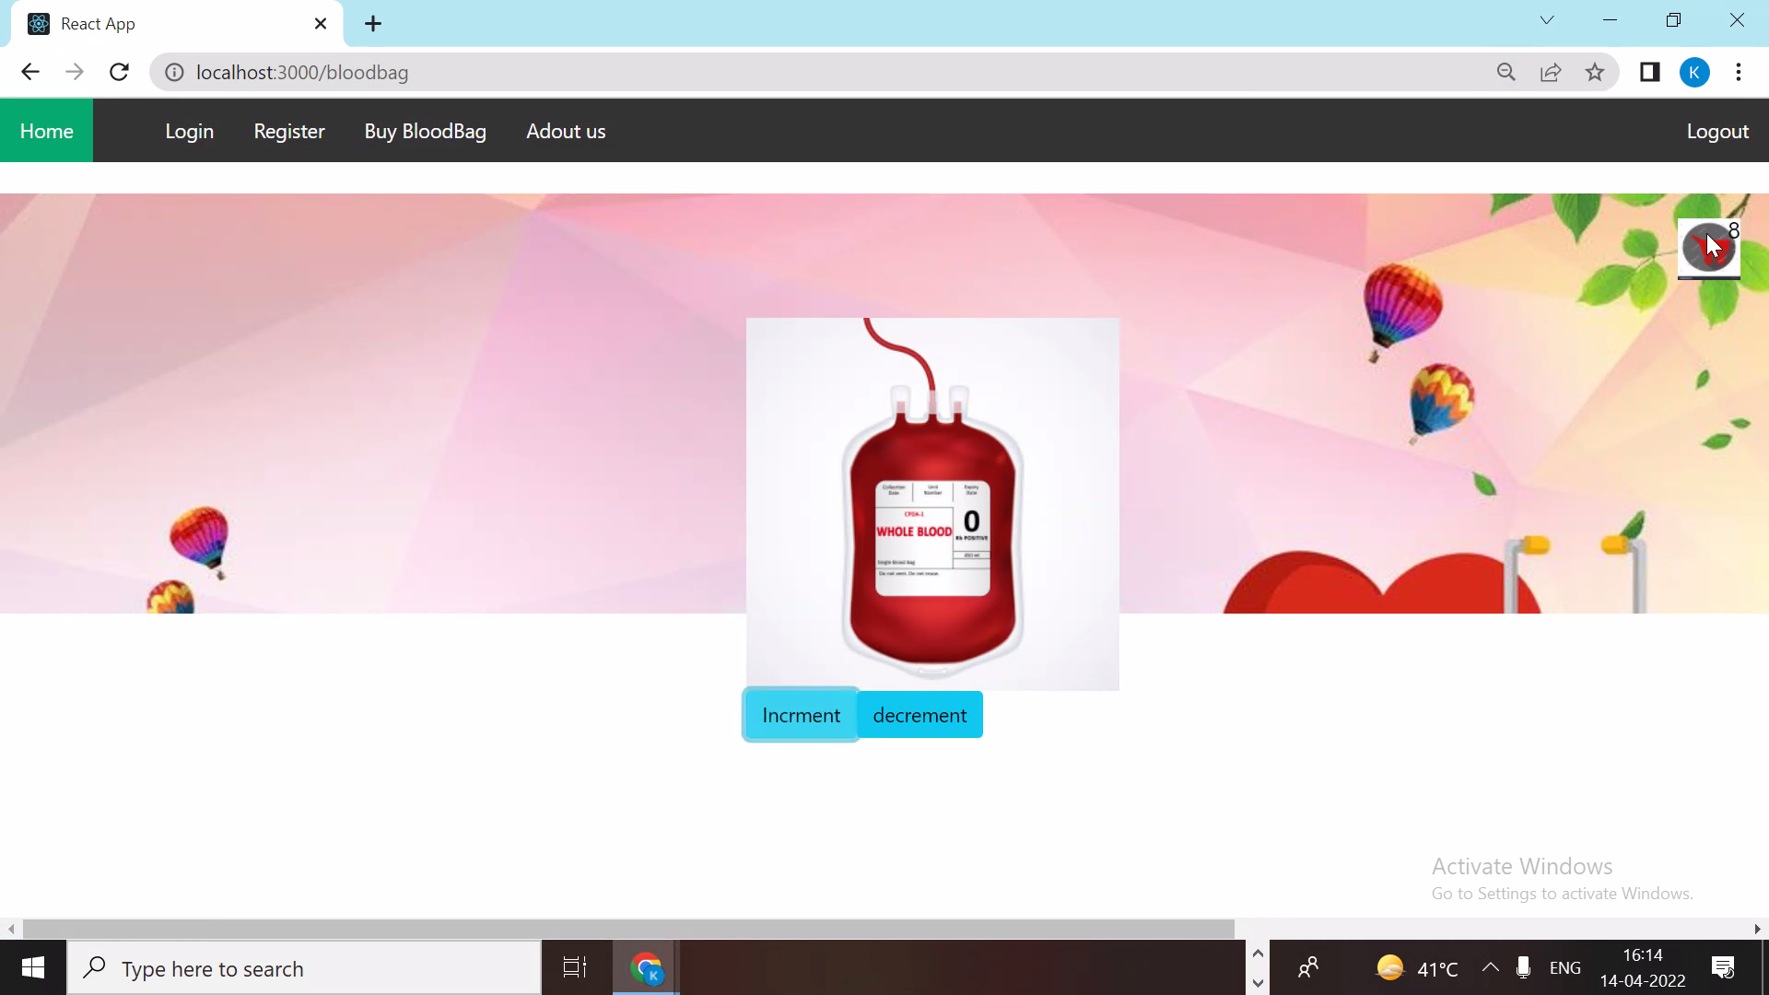

**9. CONCLUSION AND FUTURE SCOPE**

* To make technology more friendly for the patients, blood banks, hospitals and volunteer donors in context of blood donation and blood transfusion.
* To save lives by rapid access to blood related information anytime, anywhere.

**Future Scope :**

* Patients can track their order.
* Patients can make requests for fast shipping in emergency cases.